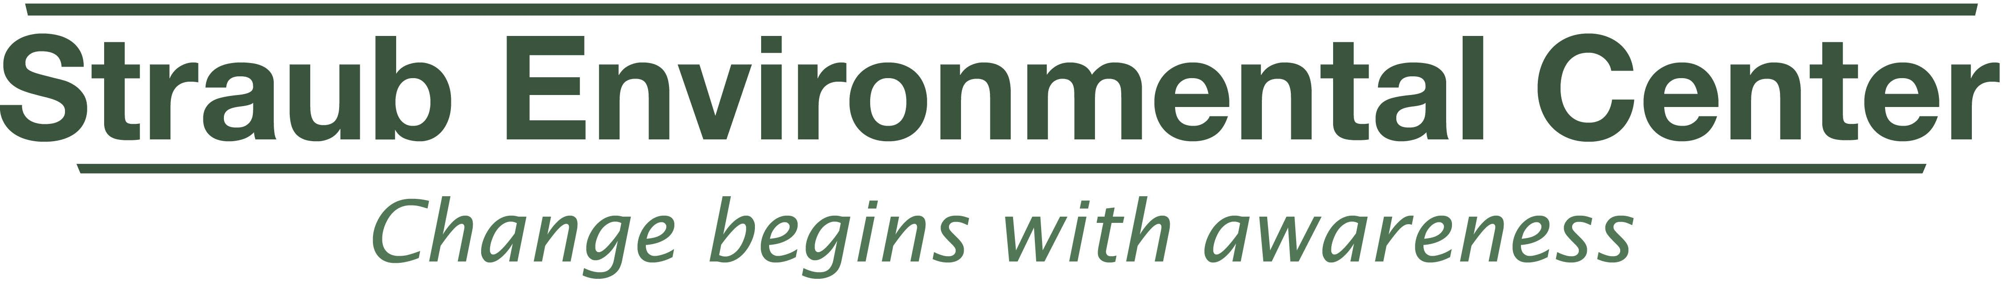
2016 Mid-Valley Green Awards Nomination Form
Green Apple Award
Please fill in all of the applicable gray boxes, save document, and then email it to: EarthWISE@co.marion.or.us

Name of person you wish to nominate:
Address:
Phone number:
Email and/or web site if available:
Who would we contact at this site?

Name of person (you!) who is nominating this person/business/organization:
How may we contact you? (Address, phone, please):

Now a word from our sponsor:
Nominees in this category may be classroom teachers or someone involved in general public education. This environmental educator not only imparts knowledge about the natural world, but provides meaningful and constructive ways for students or the public to interact with it.
In the form below, please tell us why you think your nominee would be a good choice to win the Green Apple Award and please cite examples. Feel free to expand on your explanation; the more information you can provide the better we will understand their efforts. Supporting documentation and photographs are good to add—if you have them—but they are not a substitute to completing this nomination form.

Qualifications

- The educator you wish to nominate may be in a traditional classroom setting or someone involved in community outreach. Tell us about the programs/activities that this person engages in that promote environmental education. Details are encouraged.

- What makes this person unique and/or effective in the way that they provide environmental education in our community? Provide examples if possible.
- Other information you wish to share?
Note: Be sure to save this form to your computer before you email this information back to us!

