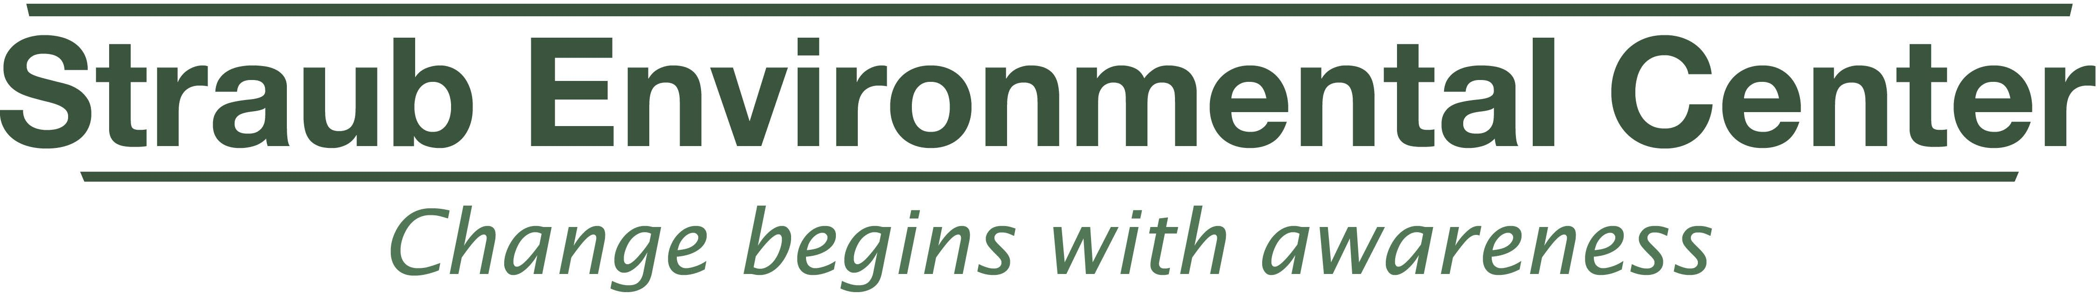
2016 Mid-Valley Green Awards Nomination Form
EarthWISE Business/Organization of the Year
Please fill in all of the applicable gray boxes, save document, and then email it to: EarthWISE@co.marion.or.us
Name of business/organization you wish to nominate:
Address:
Phone number:
Email and/or web site if available:
Who would we contact at this site?
Name of person (you!) who is nominating this business/organization:
How may we contact you? (Address, phone, please):

Now a word from our sponsor:

Nominees in this category merit this award because of their outstanding efforts in continually reducing their environmental bottom line and improving their progress on the continuum of qualifying EarthWISE criteria. EarthWISE certified businesses are committed to working toward sustainability and have documented efforts to refine their practices to protect the environment in their community. Only businesses that are EarthWISE certified prior to January 1, 2015, are eligible for nomination in this category.

In the form below, please tell us why you think your nominee would be a good choice to win a Green Award and please cite examples. Feel free to expand on your explanation; the more information you can provide the better we will understand their efforts. Also, don’t hesitate to nominate your business; the community needs to learn about your success.

Qualifications

- We would like to know just a bit about this business. Briefly, please provide an overview of what this business does and/or produces?
- Recycling – What materials does this EarthWISE business recycle; how does it go above and beyond” normal business practices?

- Reuse – Does this nominee find a way to reuse things? If so, tell us about it.

- Waste reduction - a key to sustainability. How does your nominee avoid creating waste?

- Energy conservation – What steps has this business taken to reduce energy use? Details such as amounts/dollars saved are always good to know.

- Water conservation - What steps has this business taken to reduce and/or reuse water. Details are a plus.

- Waste water/storm water protection - How does the nominee protect area streams from on-site pollutants:

- Education – EarthWISE businesses educate their staff and customers about what they do; how does this business do that:

- Sustainability—EarthWISE Businesses/Organizations of the Year go “above and beyond” both competitors in its field and in the community as a whole. What things does this nominee do that stand out above the rest?

- Other items that you wish to share about the nominee:

Note: Be sure to save this form to your computer before you email this information back to us!

